**Network Design proposal**

This report aims to cover a network installation for a company in a new three-floor building.

The main plan involves a LAN design that will be able to endure for the next five to seven years but will also be able to provide the means for any future upgrades.

The hardware of the network will consist of a number of dedicated servers and will also provide

directory services and database services. The LAN will be resilient and secure, able

to handle high-traffic loads and support voice and video communications. Moreover, it will be

cost-effective and upgradable to cater for more users.

The company consists of 4 departments: The staff, general and administrative, where each

member of both departments will have their own computer and connection to a printer and the

servers, but the admin staff will be using a shared printer; The technicians, where all of its

members will have their own computer and access to all networks but also access to a large

and secure storerooms that exist in their area.

Each department will be logically separated with the use of different subnets that will also

provide the necessary isolation so that some departments will have limited access to others.

A wireless network will also be available to provide access to the Internet to anyone from

anywhere within the company floors but will separate access from guests to managers, sales general staff and administrators or technicians by using proper security.

A high-level look at the company's proposed network topology would involve

Proposed Design

1. Cabling and connectivity

2. Logical Topology

3. Device selection and placement

IP Addressing

1. IP addressing scheme

2. Subnetting benefits

3. IP address LAN allocation

Proposed Design

For the current plan, a two-tier collapsed core hierarchical network model is proposed

because it offers the same benefits as a three-tier design such as modularity, which

facilitates scalability, isolation through subnetting, which improves resiliency and reduced

cost, as it provides the functions of the core and distribution layer in single device.

Cabling and connectivity

The whole network utilizes wired connectivity and offers restricted wireless connectivity for

those who want to bring their own devices. While wireless connectivity is easier to setup,

manage and maintain, it is not suggested in the enterprise area due to the many

disadvantages that comes with it, such as high-security risks and much slower speeds from

wired ones due to wireless signals being affected from walls, floors or other electronics.

n order to keep an organized and well-planned cabling system at the main distribution core,

the network follows a structural cabling standard such as the EIA/TIA-568, where it suggests

coloured cables with appropriate labelling and patch panels for easy management. The cables

travel from rack to rack via overhead cable pathways and with the use of vertical and horizontal

cable managers at the sides of the racks end up to their corresponding device while keeping

an organized cabling environment. This structured approach offers a reliable, scalable and

manageable cabling infrastructure

The types of cables for the network are chosen based on the types of the devices that will be

used for, as well as the layer that those devices exist in the hierarchical model. At the core

layer, the cable of choice is the CAT6 STP straight-through that is made of copper, is shielded

to protect from various interferences and supports 10GBase gigabit speeds within distances

of 55 meters. For intermediary devices and hosts the cable of choice is the CAT5e UTP

crossover which is widely used with fast ethernet connections but it also supports 1gigabit

connections. Other alternatives are the CAT7 copper cable that supports 10GBase

connections up to 100 meters and fiber optic cable that support various standards with

different modes based on its wavelength, and distances up 40 kilometers. However, for the

current plan these alternatives are cost-inefficient and redundant since that the chosen cables

can already provide the required resiliency and scalability

The below shows a sample of the logical topological diagram of the IP addressing of the floor switches and the vlans that belong to each one of the hardware used.

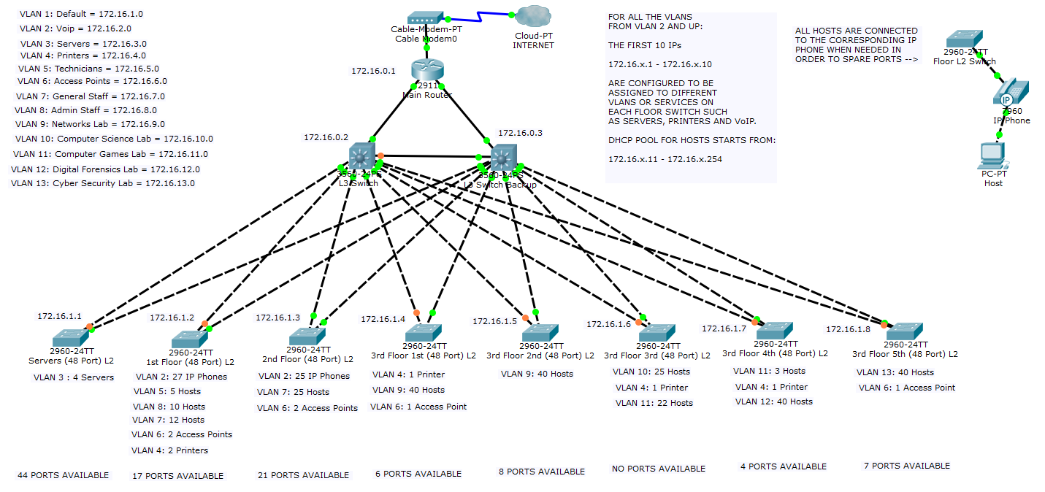

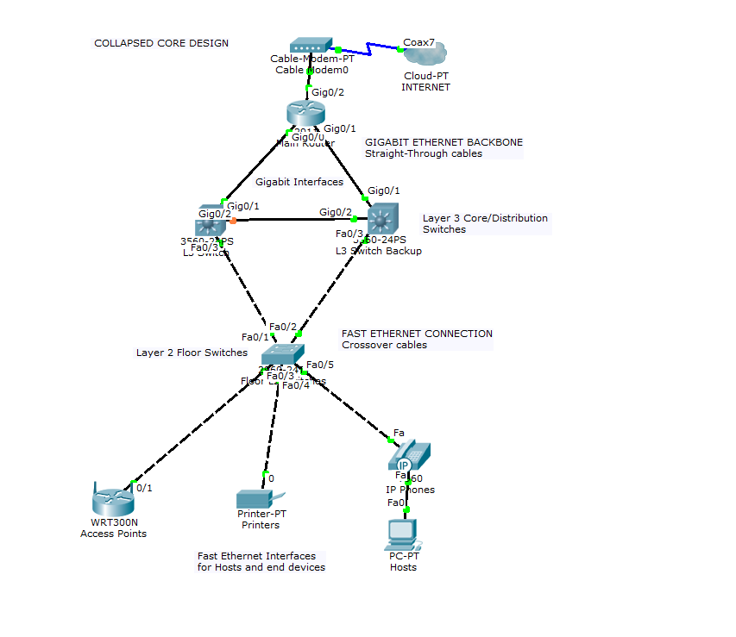

The above image shows a sample of the proposed main concept of the physical topology to be implemented throughout the network

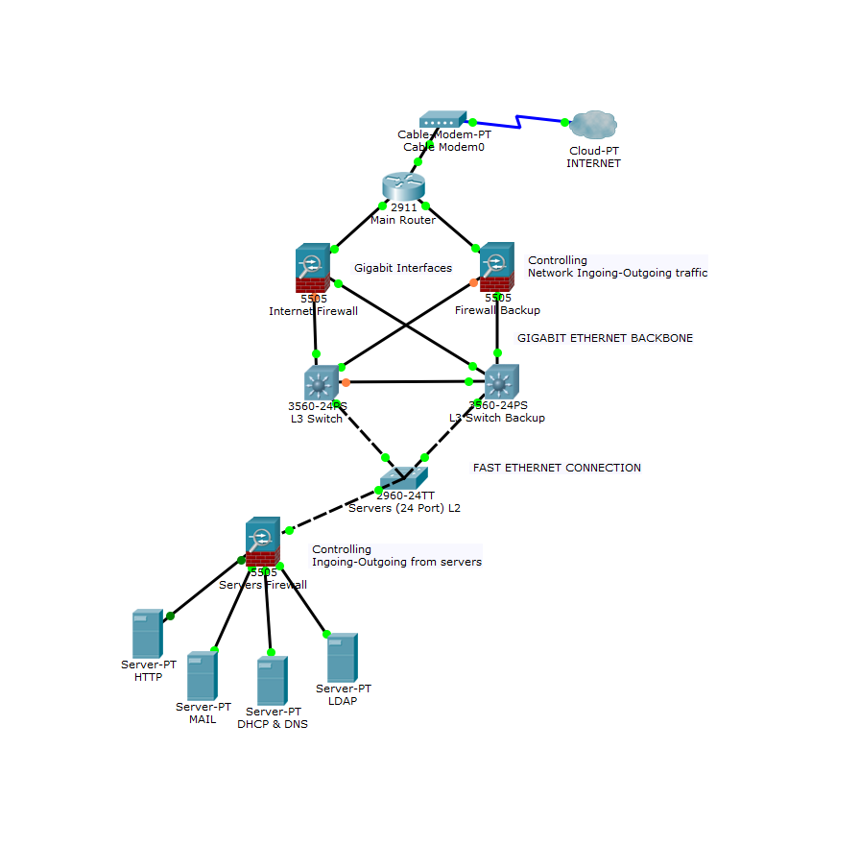

The above image shows the placement of firewalls for the servers as well as for accessing the

Internet.

Device selection and placement

The devices are chosen based on the hierarchical model that is going to be implemented. At

the core, a router operates as the default gateway and routes the traffic in and outside of the

network. At this point, two firewalls control ingoing and outgoing traffic for security purposes

as depicted in the figure above. Next, two, fixed configuration, fully managed, Layer 3 switches with 48 ports and stackable functionality, operate as the backbone. Both switches and firewalls are coupled for redundancy. The backbone of the network is placed in the large storeroom that

exists in the technician’s area for security and protection reasons.

The chosen switches are the most optimal for this plan because they offer full configuration

features such as, protection over DDNS attacks, Quality of Service and the ability to create

Virtual LANs(vlans) but are also stackable, which could be a number of switches operating as one. Alternative options were the modular switches, which offer the best

flexibility but are the most expensive, standalone, which are configured individually, or

unmanaged, which are not offering any configuration

Next on the hierarchy are 8 L2 switches with 48 ports, that are placed on each floor based

on the number of end devices, as well as 6 wireless access points, 2 for each floor.

Specifically, 2 switches are placed on the technician’s room, one for the servers and the

other one for providing connection to all the other hosts and devices on the floor, including

the two access points. Another one is used on the second floor at the large staff room, that provides connection to all the hosts at this floor and the other two access points and the remaining 5 switches are placed on the third floor in a circular placement starting from the networks to the cyber security lab in order to connect all the hosts and devices as well as the remaining 2 access points.

The number of L2 switches is chosen and placed in such way because of the

implementation of vlans which reduces the number of required switches compared to regular

subnetting, as it allows each port to operate as a separate subnet. The number of 6 access

points is chosen for increased availability at any place of the company floor and they are placed on each floor at high positions at the aisles at the left and the right side of the stairs. The access

points are configured with unique SSIDs and WPA2 security measurements so that every

authorized person will be able to login to securely to their corresponding depart but guests

will only have limited traffic-controlled access to the Internet.

The remaining devices in the topology are: the network printers in each department, one for

each lab, one for the technicians and one shared for the admin staff. The IP phones that

provide VoIP and exist at the staff’s rooms, both admin and general, and the technician’s

departments. Lastly, there are the servers at the technician’s area which are four, a HTTP, a

MAIL, a DHCP & DNS, and a LDAP for directory services and a firewall to secure the

servers

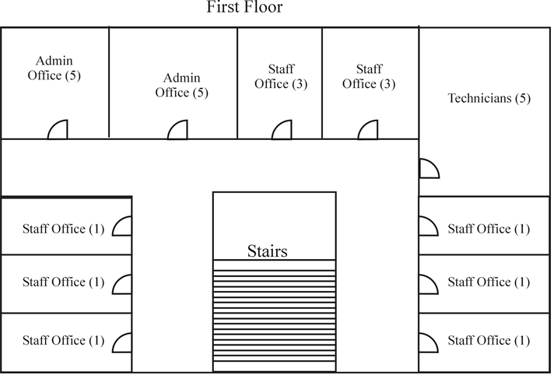

The figure depicts the Physical topology diagram for the first floor.

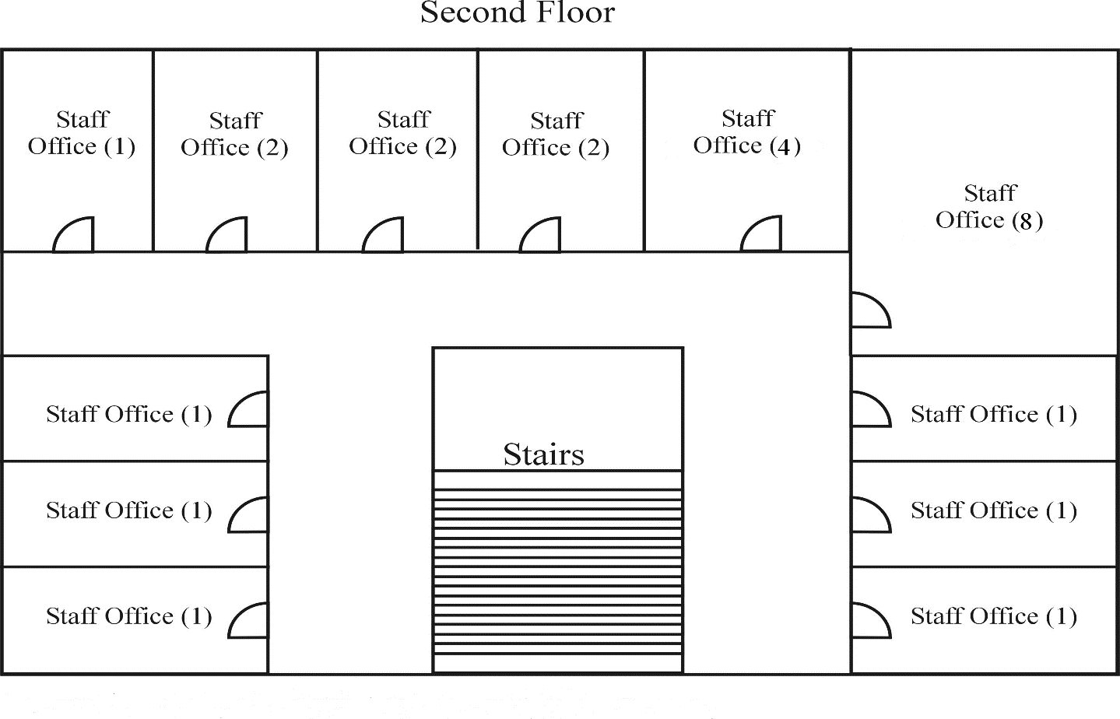

Physical topology diagram for the second floor.

IP addressing scheme

The given IP address 172.16.0.0 with subnet mask 255.255.240.0 provides a total of 16

subnets with 4094 available hosts for each subnet. However, the number of these hosts is

very large and redundant. In order to minimize the number of hosts the subnet mask is

moved 4 bits and thus giving the IP 172.16.0.0 with subnet mask 255.255.255.0. With this

subnet mask a total of 16 subnets is available but the number of hosts is reduced to 254 per

subnet. At the table below the IP addressing of all the departments is depicted.

Table showing a depiction of subnets of the various departments.

Subnetting benefits

By moving the bits on the given IP, the number of available hosts is reduced and the number

of broadcast packets that will be sent. This provides network performance and speed because it limits the traffic to a single subnet but also increases security. Even more flexibility is provided by using vlans because compared to basic subnetting implementation, the number of the switches needed is limited to individual ports. This implementation increases security even more but also keeps costs lower because the number of switches is reduced.

IP address LAN allocation

In the current IP allocation scheme, all the devices belong to separate vlans. The first one

begins with the IP address 172.16.1.0 which is assigned dynamically via DHCP servers to

the L2 floor switches and each port of these switches has a separate vlan from numbers 5

and up. The vlans 2-4 with the IPs 172.16.2.0 – 172.16.4.0 are assigned to the voIP, servers

and printers respectively as depicted in figure 1. All the vlans are configured accordingly with

the right ports so that they can get IPs from the DHCP server and have as first usable IP for

hosts the 172.16.x.11. The reason for this configuration is to allow each vlan in any floor

switch to assign an IP from 2 to 10 for accessing the servers, the printers and voIP services

and the first IP 172.16.x.1 in each vlan, as the default gateway.

Summary

The proposed design analyzed in this report provides the necessary means to cover for the

requirements of the company. The collapsed core design, combined with the appropriate

structural cabling and connectivity, provides a Gigabit network that is cost-effective and

resilient for the next five to seven years but also easily upgradeable with the use of stackable

L3 switches. Moreover, the LAN is secure logically, as a combination of firewalls, vlans and

secure wireless access points is implemented but also physically with the backbone installed

in a secured area. Finally, with the chosen IP addressing scheme and the wireless

availability on each floor, scalability and availability is also ensured.

REFERENCES

Fitzgerald, J., & Dennis, A. (2009).

Business Data Communications and Networking

(10th ed.). Hoboken, NJ: John Wiley& Sons, Inc.

Oppenheimer, P. (2010).

Top-Down Network Design: A systems analysis approach to enterprise network design

(3rd ed.).Indianapolis, IN: Cisco Press.

Dean, T. (2010).

Network+ Guide to Networks

(5th ed.). Boston, MA: Cengage Learning.

Diane, T. (2008).

Authorized Self-Study Guide Designing for Cisco Internetwork Solutions (DESGN)

(2nd ed.).Indianapolis, IN: Cisco Press.

Teare, D., & Pacquet, C. (2005).

Campus Network Design Fundamentals

. Indianapolis, IN: Cisco Press.